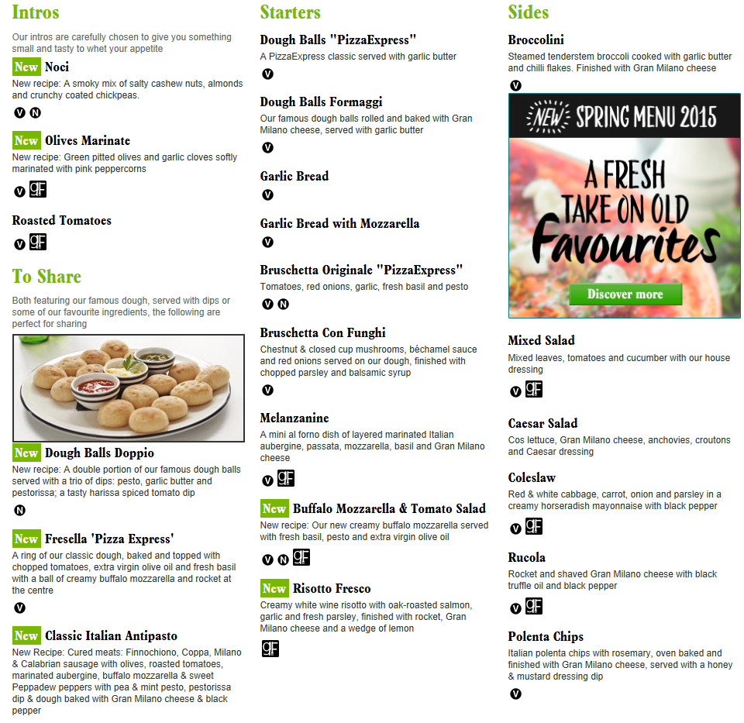

**Create a song or poem based on one of the topics from the Mass Media unit.**

***Include key terms!***

**Design a poster explaining in detail a topic from the Mass Media unit. Join your posters together to create a display board explaining the whole of the Mass Media unit. *Use MUST include key terms and make it VERY informative.***

**Create a Sociology superhero and produce a comic book about his/her Mass Media adventures and powers.**

**Create a mindmap of all the aspects of the Mass Media unit.**

**Design your own exam paper, including 2, 4,5 and 12 markers, for Mass Media.**

**Choose one piece of marked work in your book and re-do it, ensuring that you are responding to feedback and making improvements where necessary.**

**Teach a Mass Media lesson to a family member and mark the work that they produce.**

**Create a board game based on the Mass Media unit.**

***It must test knowledge and understanding.***

**Choose a topic from another subject, and show how you can link it to Mass Media.**

***Include any key terms that are similar.***

**Create a 10 minutes news clip explaining the Mass Media unit. *Interview another person about aspects of the unit.***

**Make a crossword using only key terms from the Mass Media unit.**

***Try to include them all.***

**Make a crossword using only key terms from the Mass Media unit.**

***Try to include them all.***

Takeaway Sociology Revision

**In no more than 30 words, summarise what you learnt last lesson. *Include at least 3 key terms***

**Individually create 10-15 challenging quiz questions about the topic from Mass Media you have chosen. Pair up with someone else and test each other. *Make sure you use command words from the exam, i.e. Explain, Discuss.***

**Work together with someone to create a flow diagram to explain the Mass Media unit. *You need to put a lot of detail in them as well as key terms. ***

**Pair up with someone else from your class and explain your ‘intros’ to each other. *Remember you’re peer teaching!***

**Write three tweets summarising the topic you have chosen from the Mass Media unit.**

***No more than 140 characters; use #’s to highlight key terms.***

**Create a mind map summarising the topic from Mass Media. *Make it informative but catchy, you MUST include key terms!***

**Identify all the key terms you have come across during the Mass Media unit. *Define them and draw images to represent them.***